**Enrichment and isolation of Hydrogen-Oxidizing bacteria and heterotrophs from soil**

Elham Ehsani1, Charles Dumolin2, Silvio Matassa3, Aurlien Calrier2, Peter Vandamme2, Nico Boon1*

1Center for Microbial Ecology and Technology (CMET), Coupure Links 653, B-9000 Gent, Belgium

2Laboratory for Microbiology, Gent University, K. L. Ledeganckstraat 35, B-9000 Gent, Belgium

* Corresponding author: Nico Boon, Ghent University; Faculty of Bioscience Engineering; Center for Microbial Ecology and Technology (CMET); Coupure Links 653; B-9000 Gent, Belgium; phone: +32 (0)9 264 59 76; fax: +32 (0)9 264 62 48; E-mail: [Nico.Boon@UGent.be](mailto:Nico.Boon@UGent.be); Webpage: [www.cmet.UGent.be](http://www.cmet.UGent.be).

**Introduction:**

Soil is one of the most diverse and important ecosystem on earth (1). Microorganisms play an important role in soil environment such as recycling of organic compounds (carbon, nitrogen or sulfur), decomposing compounds and providing symbiotic associations with the roots of legumes. Soil is a complex and heterogeneous environment contains enormous microbial community and species diversity which contains 109 to 1010 microorganisms with a 103 to 106 unique species of bacteria per gram of it (2, 3). Based on the most studies of 16S rRNA gene sequencing, *Proteobacteria*, *Actinobacteria*, *Firmicutes* and *Bacteroidetes* arefour frequent phylogenetic groups in all types of soil *(4)*.

Hydrogen-oxidizing bacteria (HOB) are aerobic, facultative autotrophic bacteria which has an ability to utilize hydrogen as electron donor and oxygen as electron acceptor to fix carbon dioxide into new cellular material (5). In addition of H2, they can oxidize organic substrates such as sugars, amino acids and organic acids as source of energy, therefore many of them can grow in mixotrophic conditions. The common molar ratios of gaseous substrate composition in hydrogen-oxidizing bacteria reported previously ( H2/O2/CO2 = 7:1:1 or 7:2:1 (v/v)) (6, 7). They are a taxonomically heterogeneous group of bacteria comprise of Gram-negative or Gram-positive genera (8). HOBs are known as producer of single cell protein (SCP) and polyhydroxybutyrate (PHB). PHB, a raw material for bioplastic production, is generated by bacteria when low concentration of compounds are available (5, 6) and also acts as microbial control agents and anti-infective agents in aquaculture (9). Autotrophic HOB can also produce microbial protein with all the essential amino acids profile near to high-quality animal protein composition, Which make them a good feasible candidate as protein source for human and animal nutrition (10).

In order to enrich HOB culture, process conditions like sequence batch and continuous can be applied. It was found that microbial community can be changed with different process conditions. Under sequence batch condition the coexistence of a microbial diversity is stimulated, while under continuous condition this is nailed down to a one species dominated culture (11).

A broad range of techniques has been used for dereplication of bacterial isolates, but the suitable technique should have some criteria like simplicity, reliability, high specificity, applicability to all bacterial strains with low costs (12). Matrix-assisted laser desorption ⁄ionization time-of-flight mass spectrometry (MALDI-TOF MS) complies these requirements and has become an important high throughput dereplication tool for species to strain level identification in environmental, medical and food-related studies (13, 14). MALDI-TOF MS generates easy interpretable data based on protein mass spectra corresponding to ribosomal proteins, discriminating wide range of bacterial species which could be semi-automated, fast and cheap analysis (15, 16).

In the present study, we aimed to enrich and isolate Hydrogen-oxidizing bacteria and heterotrophs from soil and dereplicate them by MALDI-TOF MS. 16S rRNA gene amplicon sequencing and NRDA sequencing were performed to validate the results of MALDI-TOF MS.

**Material and methods**

Enrichment of hydrogen-oxidizing bacteria by reactor

The upper 10cm rhizosphere soil sample was collected from Almoeseneie forest (Gontrode, Belgium) from the area with a pH of 4,4. The enrichment was carried out by sequencing batch and using electrolysis cell to produce H2 and O2 to enrich HOB community. The electrolysis of water is considered to produce oxygen and hydrogen gas. The core of an electrolysis unit was an electrochemical cell with two electrodes which was filled with H2SO4 solution (0.5M) and was connected with an external power supply. At a voltage of 3.7, the electrodes start to produce hydrogen and oxygen gas at the negatively and positively biased electrodes respectively. Bicarbonate solution was used to produce CO2 as a carbon source and refreshed daily to have enough CO2 concentration which was connected after electrolysis cell (Supplementary Figure 1).

The mineral media was prepared for HOB isolation and culturing based on previous study (17). The culture flask with a volume of 500 ml (Glasgeratebau Ochs, Bovenden/Lenglern, Germany) was placed in a 28° C temperature room with a volume of 300 ml of mineral media inoculated with 10g of soil as a start point. Another flask with HOB microbiome was installed to the reactor as a positive control, both flasks were stirred at 700 rpm to ensure completely mixed condition. Filters and gas sampling ports were placed before each bottle to prevent the contamination and checking the gas concentration respectively. HOB enrichment and growth was monitored by NH4-N consumption and Chemical Oxygen demand measurement (COD) to measure COD-biomass increasing, so when ammonium nitrogen was consumed, 30 ml of bacterial culture was withdrawn and diluted into 270 ml of fresh mineral medium (refreshing culture 10%) to restart the enrichment with new batch. In total 6 times refreshing were done during the experiment (sixth batches). Samples were taken after each batch and sent to Illumina Miseq sequencing and the culture was collected for HOB and heterotrophs isolation after 6th batch.

Analytical method

NH4+–N concentration was determined by ion chromatography (IC 761 compact, Metrohm, Switzerland). Total and soluble chemical oxygen demand (CODt and CODs) were measured according to dichromate method (18). Prior to measure soluble COD (CODs), samples were filtered by 0.45µm filter and then, COD biomass (CODb) determined based on the difference between CODt and CODs. The compact Gas Chromatography (GC)(Global Analyser Solution, The Netherlands) was equipped with a thermal conductivity detector and was used to check the concentrations of three gas samples before each flask.

Microbial community analysis

DNA was extracted after each batch using the FastPrep®-24 Instrument (MP Biomedicals; Illkirch, France) as previously described (19) and the DNA quality was evaluate on 1% (w/v) agarose gel electrophoresis. The V3-V4 hypervariable region of the 16S rRNA gene (20) was amplified and libraries were sequenced in a Miseq platform (Illumina) according to the manufacture’s guidelines at LGC Genomic GmbH (Berlin, Germany). This generated 50,000 (± 30 %) raw 2 x 300 bp paired-end reads per sample. Contigs were created by merging paired-end reads based on the Phred quality score heuristic (21) in MOTHUR (v.1.37, seed = 777) (22). Contigs were aligned to the SILVA database and filtered. Chimera removal was performed by using *uchime* command. Ultimately, OTU's were clustered with an average linkage and at the 97% sequence identity. The data-set was then filtered to consider only those phylotypes that were present in at least one sample at a relative abundance > 0.1% or were present in all samples at a relative abundance >0.001% as previously defined (23).

Isolation by plating and dilution to extinction

Enriched soil culture after sixth batch by reactor was used for the isolation by plating and isolation by dilution to extinction. Isolation by plating was performed by preparing serial dilutions of enriched culture, then cultured on plates on diluted nutrient broth (DNB 1/10), Gelzan TM CM or gellan gum (Sigma, 10 g/l), MGSO4.7H2O (0.5 g/l) and 10 ppm cyclohexane (10 ml/l, to prevent fungal growth) in distilled water. All ingredients except cyclohexane was autoclaved at 121°C for 15 min, cooled to 50°C then the filtered cyclohexane was added to the solution.. After visual appearance of colonies, isolates were picked by the K2 colony picker (KBiosystems, Basildon, UK) and transferred into 96 well microtitre plates containing the same medium. Colonies were sub-cultured three times in DNB and ultimately dereplication of bacterial isolates was done by MALDI-TOF MS..

On the other hand, dilution to extinction method was used to isolate bacteria from enrichment soil culture with the concentration of H2, O2 and CO2. Therefore several serial dilutions of enriched culture were made in 96 well plates, placed in the plastic bag and installed to the reactor. The gas inlet and outlet were embedded by tubing to the plastic bag and sealed properly. After observations of liquid culture turbidity by the naked eye, the liquid was cultured in plates with same media (mineral salt) and gellan gum then placed in the plastic bag until appearance of colonies. For identification of colonies, sanger sequencing was performed on the 16S rRNA amplicons (16S rRNA genes were amplified by 63F and 1378R) (25), aligned and compared to sequences from the National Center for Biotechnology Information (NCBI) database afterward the closest match of each colonie was identified.

Matrix-assisted laser desorption ionization time of flight mass spectrometry (MALDI-TOF MS)

Sample preparation:

Around 1000 bacterial cells were sub-cultured three times in 96 deepwell plates and incubated at 28°C, then MALDI-TOF MS analysis was performed. Prior to cell extraction, bacterial cultures were washed three times by centrifugation (10 min, 10,000 g, 4°C) and resuspending in 300µl Milli-Q water. After third centrifugation, bacterial cultures were resuspended in 300µL Mili-Q water and 900µL of absolute ethanol was added. Next, supernatant was removed after centrifugation (10 min, 10,000 g, 4°C) and 50 µl 70% formic acid and 50 µl acetonitrile were added to the bacterial cell pellet. The extracts were centrifuged (10 min, 10,000 g, 4°C) and supernatant was used for MALDI-TOF MS analysis.

Maldi-tof MS analysis:

Bacteria1 cell extracts (1 µl) were spotted in duplicate onto a MBT Biotarget 96 target plate (Bruker Daltonics, Germany). After drying at room temperature, spots were overlaid with 1 µl matrix solution (5 mM α-cyano-4-hydroxycinnamic acid (α-CHCA) in 50:48:2 acetonitrile:water:trifluoroacetic acidsolution). Mass spectra were generated with a Microflex BiotyperTM (Bruker Daltonics, Germany) using manufacturer’s standard setting. Each series of measurements was preceded by calibration with a bacterial test standard (BTS 155 255343; Bruker Daltonics), to calibrate the instrument and validate the run. Mass spectra were exported and further analyzed by curve-based analysis using the BioNumerics 7.2.6 software (Applied Maths, Belgium). The similarity between the spectra was expressed using Pearson's product moment correlation coefficient and the spectra were clustered using the UPGMA clustering algorithm.

Identification of isolates:

Of each MALDI-TOF MS profile cluster representatives were selected for tentative identification by 16s rRNA gene sequence analysis and identified using the EZ taxon database. Isolates identified as *Achromobacter sp.* were more accurately indentified to the species level through nrdA sequence analysis, as described previously (26).

**Results:**

Soil has been enriched by applying electrolysis cell to produce H2 and O2 with refreshing culture sixth times till 6th batch for 130 days and growth has been monitored by measuring NH4-N consumption and CODb. NH4-N was consumed at the end of each batch while CODt and CODb increased during the time in all batches (Figure. 1). COD measurement was monitored after third batch because at first and second batch, the COD results were affected by soil. The results of gas measurement showed two volume of hydrogen to one volume of oxygen and hydrogen flow was 10 ml/min.

Enrichment soil culture of the 6th batch was used to isolate the bacteria by plating and dilution to extinction, moreover 16S rRNAgene amplicon sequencing was applied to assess the composition of the microbial community at the end of each batch.

Microbial community composition

To visualize the distribution of the different OTUs in all 6 batches, a heat map was generated from R package gplots (27), considering only those phylotypes present in at least one sample at a relative abundance > 0.1% (Fig. 2). *Proteobacteria* and *Bacteroidetes* were found more abundant phylum in all batches respectively. The results of amplicon sequencing of the 6th batch showed presence of 25 different species after filtering. Among the group of *Proteobacteria* (74%), *Betaproteobacteria* (65%) and *deltaproteobacteria* (7%) were found more abundant in 6th batch with more *Achromobacter* (63%) and *Bdellovibrio* (7%) species respectively. On the other hand, among the *Bacteroidetes* (24%) group, *Leadbetterella* (10%) and *Dyadobacter* (3%) were observed more abundant in *Cytophagia* (14%) and *Pedobacter* (6%) in *Sphingobacteria* (9%) respectively. *Bdellovibrio* became one of the most abundant bacteria in the batch 5 and 6, a predatory bacterium that parasitize gram negative bacteria by entering into their periplasmic space (28). *Hydrogenophaga* was more abundant in all batches except last one which was reported that has an ability to carry out autotrophic oxyhydrogen metabolism. Pairwise distance between second batch with other batches and different batches respectively were calculated by Jaccard distance measurement by applying amplicon sequencing data (Fig. 3). Relationship between bacterial communities in second batch with other six batches showed more dissimilarity between this and sixth in comparison with other batches. The total bacterial community in fourth and fifth batches were showed less Jaccard distance than others which revealed similarity between these two batches.

Isolation by plating and dilution to extinction

Isolation by plating and dilution to extinction were performed by using enriched soil culture from 6th batch (Fig. 4). In total around 1000 colonies were picked by colony picker through the isolation by plating method. All colonies were cultured by several sub cultivations then were followed by maldi-tof dereplication. 42 representatives were found by maldi-tof dereplication with the 71% cut off value and showed most of them were *Achromobacter* species but with different profiles that suggested that they belong to different *Achromobacter* species. Nrda sequencing was performed to validate the results of MALDI-TOF MS and identify other unknown representative. In contrast to MALDI-TOF MS results, Nrda sequencing showed only 1 *Achromobacter* specie and *Thermomonas*, *Pedobacter* and *Kaistia* were also found as unknown representative with MALDI-TOF MS.

On the other hand, *Hydrogenophaga*, *Bdellovibrio* and *Sphingomonas* were isolated by dilution to extinction method by applying electrolysis cell to produce H2, O2 and CO2.

Maldi-tof

**Discussions**

The present study described the enrichment, isolation and identification of bacterial strains capable of . Enrichment was achieved by applying electrolysis cell to produce H2 and O2 gases.

**Acknowledgments**

This work was founded by a research grant from the Geconcerteerde Onderzoeksacties (GOA) of Ghent University (BOF15/GOA/006) and the Inter-University Attraction Pole (IUAP) µ-manager financed by the Belgian Science Policy (BELSPO) (grant P7/25).

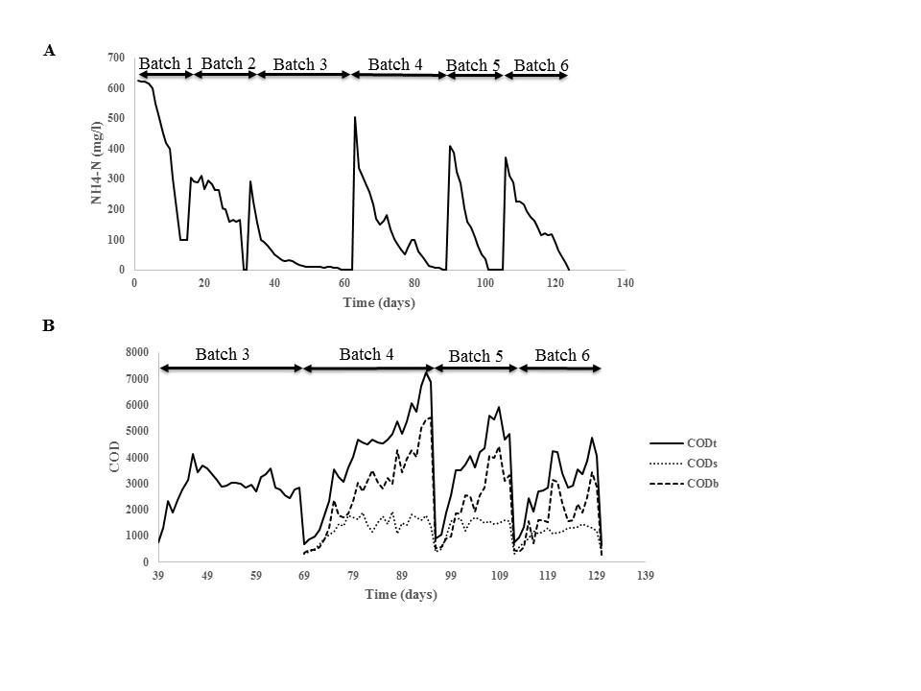Figure 1: Bacterial enrichment and growth was monitored by NH4-N consumption and COD biomass measurement for 130 days. (A) NH4-N has consumed at the end of each batch by bacteria during 6 batches. (B) COD biomass has increased at the end of each batch, increased to 5-6 g/l in 4th batch.

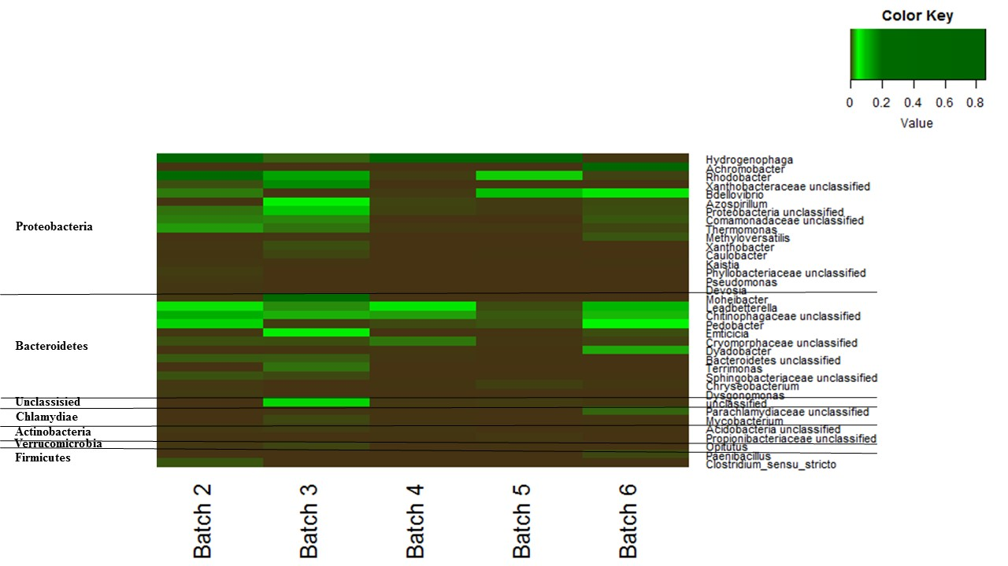

Figure 2. Heat map representing all OTUs present in all batches. The color intensity in each panel shows the percentage of a genus in a batch, referring to color key at the right top. Dark red indicates abundant genera and black indicates less abundant genera. Taxonomy is shown at the phylum level (left column) and at the lowest determined i.e. order or genus level (right column).



Figure 3. Relationship between bacterial communities in all batches generated from Jaccard distance matrices. These two graphs illustrate comparisons of the total bacterial community by 16S amplicon sequencing. (A) Comparison of bacterial community of second batch with all batches, (B) comparison between bacterial community of all batches respectively.



FiggFigure 4. The results of 16S amplicon sequencing data of batch 6 and member of some genus isolated with plating and dilution to extinction methods. Y axis showed the present of 25 bacteria in batch 6 which were sequenced and X axis showed the percentage of them in this batch. *Achromobacter*, *Pedobacter*, *Thermomonas* and *Kaistia* were isolated by plating; *Bdellovibrio*, *Hydrogenophaga* and *Sphingobacteria* were isolated by dilution to extinction.

FigureFfff

**References**

1. **Young IM, Crawford JW.** 2004. Interactions and self-organization in the soil-microbe complex. Science **304:**1634-1637.

2. **Fierer N, Jackson RB.** 2006. The diversity and biogeography of soil bacterial communities. Proc Natl Acad Sci U S A **103:**626-631.

3. **Gans J, Wolinsky M, Dunbar J.** 2005. Computational improvements reveal great bacterial diversity and high metal toxicity in soil. Science **309:**1387-1390.

4. **Hugenholtz P.** 2002. Exploring prokaryotic diversity in the genomic era. Genome Biol **3:**REVIEWS0003.

5. **Khosravi-Darani K, Mokhtari ZB, Amai T, Tanaka K.** 2013. Microbial production of poly(hydroxybutyrate) from C(1) carbon sources. Appl Microbiol Biotechnol **97:**1407-1424.

6. **Tanaka K, Miyawaki K, Yamaguchi A, Khosravi-Darani K, Matsusaki H.** 2011. Cell growth and P(3HB) accumulation from CO2 of a carbon monoxide-tolerant hydrogen-oxidizing bacterium, Ideonella sp. O-1. Appl Microbiol Biotechnol **92:**1161-1169.

7. **Volova TG, Kiselev EG, Shishatskaya EI, Zhila NO, Boyandin AN, Syrvacheva DA, Vinogradova ON, Kalacheva GS, Vasiliev AD, Peterson IV.** 2013. Cell growth and accumulation of polyhydroxyalkanoates from CO2 and H2 of a hydrogen-oxidizing bacterium, Cupriavidus eutrophus B-10646. Bioresour Technol **146:**215-222.

8. **Schink B, Schlegel HG.** 1978. Hydrogen metabolism in aerobic hydrogen-oxidizing bacteria. Biochimie **60:**297-305.

9. **Najdegerami EH, Tran TN, Defoirdt T, Marzorati M, Sorgeloos P, Boon N, Bossier P.** 2012. Effects of poly-beta-hydroxybutyrate (PHB) on Siberian sturgeon (Acipenser baerii) fingerlings performance and its gastrointestinal tract microbial community. FEMS Microbiol Ecol **79:**25-33.

10. **Volova TG, Barashkov VA.** 2010. [Characteristics of proteins synthesized by hydrogen-oxidizing microorganisms]. Prikl Biokhim Mikrobiol **46:**624-629.

11. **Matassa S, Verstraete W, Pikaar I, Boon N.** 2016. Autotrophic nitrogen assimilation and carbon capture for microbial protein production by a novel enrichment of hydrogen-oxidizing bacteria. Water Res **101:**137-146.

12. **Doan NT, Van Hoorde K, Cnockaert M, De Brandt E, Aerts M, Le Thanh B, Vandamme P.** 2012. Validation of MALDI-TOF MS for rapid classification and identification of lactic acid bacteria, with a focus on isolates from traditional fermented foods in Northern Vietnam. Lett Appl Microbiol **55:**265-273.

13. **Andres-Barrao C, Benagli C, Chappuis M, Ortega Perez R, Tonolla M, Barja F.** 2013. Rapid identification of acetic acid bacteria using MALDI-TOF mass spectrometry fingerprinting. Syst Appl Microbiol **36:**75-81.

14. **Clark AE, Kaleta EJ, Arora A, Wolk DM.** 2013. Matrix-assisted laser desorption ionization-time of flight mass spectrometry: a fundamental shift in the routine practice of clinical microbiology. Clin Microbiol Rev **26:**547-603.

15. **Ghyselinck J, Van Hoorde K, Hoste B, Heylen K, De Vos P.** 2011. Evaluation of MALDI-TOF MS as a tool for high-throughput dereplication. J Microbiol Methods **86:**327-336.

16. **Siegrist TJ, Anderson PD, Huen WH, Kleinheinz GT, McDermott CM, Sandrin TR.** 2007. Discrimination and characterization of environmental strains of Escherichia coli by matrix-assisted laser desorption/ionization time-of-flight mass spectrometry (MALDI-TOF-MS). J Microbiol Methods **68:**554-562.

17. **Yu J, Dow A, Pingali S.** 2013. The energy efficiency of carbon dioxide fixation by a hydrogen oxidizing bacterium. Int J Hydrogen Energy **38:**8683-8690.

18. **Yao N, Wang J, Zhou Y.** 2014. Rapid determination of the chemical oxygen demand of water using a thermal biosensor. Sensors (Basel) **14:**9949-9960.

19. **Vilchez-Vargas R, Geffers R, Suarez-Diez M, Conte I, Waliczek A, Kaser VS, Kralova M, Junca H, Pieper DH.** 2013. Analysis of the microbial gene landscape and transcriptome for aromatic pollutants and alkane degradation using a novel internally calibrated microarray system. Environ Microbiol **15:**1016-1039.

20. **Klindworth A, Pruesse E, Schweer T, Peplies J, Quast C, Horn M, Glockner FO.** 2013. Evaluation of general 16S ribosomal RNA gene PCR primers for classical and next-generation sequencing-based diversity studies. Nucleic Acids Res **41:**e1.

21. **Kozich JJ, Westcott SL, Baxter NT, Highlander SK, Schloss PD.** 2013. Development of a dual-index sequencing strategy and curation pipeline for analyzing amplicon sequence data on the MiSeq Illumina sequencing platform. Appl Environ Microbiol **79:**5112-5120.

22. **Schloss PD, Westcott SL, Ryabin T, Hall JR, Hartmann M, Hollister EB, Lesniewski RA, Oakley BB, Parks DH, Robinson CJ, Sahl JW, Stres B, Thallinger GG, Van Horn DJ, Weber CF.** 2009. Introducing mothur: open-source, platform-independent, community-supported software for describing and comparing microbial communities. Appl Environ Microbiol **75:**7537-7541.

23. **Camarinha-Silva A, Jauregui R, Chaves-Moreno D, Oxley AP, Schaumburg F, Becker K, Wos-Oxley ML, Pieper DH.** 2014. Comparing the anterior nare bacterial community of two discrete human populations using Illumina amplicon sequencing. Environ Microbiol **16:**2939-2952.

24. **Shungu D, Valiant M, Tutlane V, Weinberg E, Weissberger B, Koupal L, Gadebusch H, Stapley E.** 1983. GELRITE as an Agar Substitute in Bacteriological Media. Appl Environ Microbiol **46:**840-845.

25. **Heuer H, Krsek M, Baker P, Smalla K, Wellington EM.** 1997. Analysis of actinomycete communities by specific amplification of genes encoding 16S rRNA and gel-electrophoretic separation in denaturing gradients. Appl Environ Microbiol **63:**3233-3241.

26. **Spilker T, Vandamme P, Lipuma JJ.** 2012. A multilocus sequence typing scheme implies population structure and reveals several putative novel Achromobacter species. J Clin Microbiol **50:**3010-3015.

27. **Warnes GR BB, Bonebakker L, Gentleman R, Huber W, Liaw A, Lumley T, Maechler M, Magnusson A, Moeller S, Schwartz M, Venables B.** 2012. gplots: various R programming tools for plotting data.

28. **Rendulic S, Jagtap P, Rosinus A, Eppinger M, Baar C, Lanz C, Keller H, Lambert C, Evans KJ, Goesmann A, Meyer F, Sockett RE, Schuster SC.** 2004. A predator unmasked: life cycle of Bdellovibrio bacteriovorus from a genomic perspective. Science **303:**689-692.